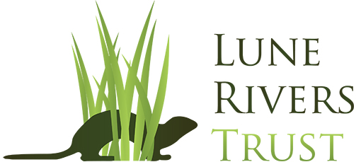

VACANCY ANNOUNCEMENT
Job Title: Farm Advisor/ Project Officer

Purpose: To deliver one main project: Providing farm advice, support and training for our United Utilities farmer engagement project.

Reports to: Trust Manager

Location: Currently a mixture of home-based working and in the Lune Rivers Trust office in Morecambe. Frequent site work will be required at locations across the Lune catchment, particularly in the Kirkby Lonsdale area.

Hours: Full-time 37.5 hours per week.

Salary: £22,724

Contract: 12 month fixed term contract (with potential to extend)

The Lune Rivers Trust is a small but ambitious environmental charity dedicated to the protection and enhancement of all the rivers and tributaries in the Lune catchment. We are looking for a motivated and enthusiastic person to join our team and to run one of our projects.

In 2022, the Trust was successful in securing funding from United Utilities for a new farmer engagement project. The overall objective of this project is to improve water quality in the River Lune by working with farmers in the Lune catchment. The project will look at how changes to farm infrastructure, land use and farming practices could benefit the environment whilst also supporting the farm businesses. As part of this project, and building on our other ongoing projects, we are looking for a second Farm Advisor/ Project Officer to work alongside our current team.

We are just at the start of this project, and have yet to design in detail where and how the project will be carried out. It is envisaged that part of the project will be continuing the work that we have been doing for the past several years with farmers in the Tebay and Wenning areas of the catchment. We also plan to launch farmer engagement activities in other areas of the catchment, and are particularly interested in the Kirkby Lonsdale to Lancaster area. It is this second aspect which will be the key responsibility of the new Farm Advisor/ Project Officer.

DUTIES AND RESPONSIBILITIES
- Work with the Trust Manager and current Farm Advisor to choose the new operational area and scope of activities for the project.
- Establish contact with farmers in the operational area and enrol interested farmers onto the project.
- Work with specialists to undertake assessments of farms enrolled onto the project (e.g. Farm Infrastructure Audits, Nutrient Management Plans).
- Work with farmers to select priority actions to reduce diffuse pollution issues identified by the farm assessments and oversee implementation of activities to address these.
- Provide farm advice and training events to improve farmers’ knowledge around diffuse pollution and support the delivery of measures identified.
- Coordinate with LRT’s Woodlands Officer to ensure enrolled farmers are aware of woodland creation opportunities, and assist them where necessary with accessing funding.
- Maintain effective liaison with other catchment partners involved in these areas (Yorkshire Dales National Park Authority, Environment Agency, Natural England, Forestry Commission, Woodland Trust, Lancaster City Council and local stakeholder groups).
- Work with the Trust Manager to develop future funding bids.
- Assist with other LRT projects as necessary.

How to apply:

If you would like more information, or an informal chat, about the post please contact Tim Pitt (Trust Manager) on 079 49 24 26 55 or tim@luneriverstrust.org.uk .

To apply for this post please send a current CV and covering letter to the email address tim@luneriverstrust.org.uk explaining why this position is of interest to you, the skills and experience you can offer, how you meet the criteria set out in the Person Description, and other information you consider relevant.

Closing date for applications: Midnight 18th September 2022.

